# Data Structures Lab 01

**Course:** Data Structures (CS2001) **Semester:** Spring 2024

**Instructor:** Bushra Sattar **T.A:** N/A

**Note:**

* Maintain discipline during the lab.
* Listen and follow the instructions as they are given.
* Just raise your hand if you have any problem.
* Completing all tasks of each lab is compulsory.
* Get your lab checked at the end of the session.

# 2D Arrays, Pointers and Double Pointers

**2D Arrays**

A two-dimensional array in C++ is the simplest form of a multi-dimensional array. It can be visualized as an array of arrays. The image below depicts a two-dimensional array.

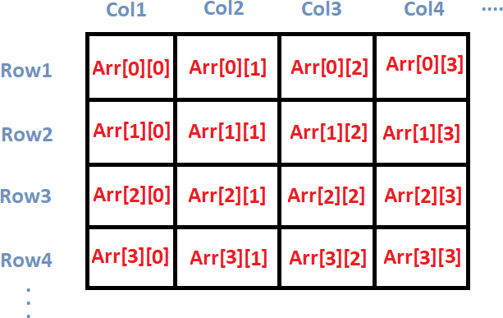

A two-dimensional array is also called a matrix. It can be of any type like integer, character, float, etc. depending on the initialization.

# [Initializing a 2D array in C++](https://www.digitalocean.com/community/tutorials/two-dimensional-array-in-c-plus-plus#initializing-a-2d-array-in-c)

we initialize a 2D array arr, with 4 rows and 2 columns as an array of arrays. Each element of the array is yet again an array of integers.

int arr[4][2] = {

{12, 56},

{2, 33},

{3, 80},

{3, 78}

# [Printing a 2D Array in C++](https://www.digitalocean.com/community/tutorials/two-dimensional-array-in-c-plus-plus#printing-a-2d-array-in-c)

#include<iostream> using namespace std; main( )

{

int arr[4][2] = {

{ 10, 11 },

{ 20, 21 },

{ 30, 31 },

{ 40, 41 }

} ;

int i,j;

cout<<"Printing a 2D Array:\n"; for(i=0;i<4;i++)

{

for(j=0;j<2;j++)

{

cout<<"\t"<<arr[i][j];

}

cout<<endl;

}

}

**Output**

|  |  |
| --- | --- |
| 10 | 11 |
| 20 | 21 |
| 30 | 31 |
| 40 | 41 |

**What are Pointers?**

A pointer is a variable whose value is the address of another variable. Like any variable or constant, you must declare a pointer before you can work with it. The general form of a pointer variable declaration is: **Syntax: type *var-name;**

Here, type is the pointer's base type; it must be a valid C++ type and var-name is the name of the pointer variable. The asterisk you used to declare a pointer is the same asterisk that you use for multiplication. However, in this statement the asterisk is being used to designate a variable as a pointer.

# Following are the valid pointer declaration

int *ip; // pointer to an integer double *dp; // pointer to a double float *fp; // pointer to a float char *ch // pointer to character

The actual data type of the value of all pointers, whether integer, float, character, or otherwise, is the same, a long hexadecimal number that represents a memory address. The only difference between pointers of different data types is the data type of the variable or constant that the pointer points to.

Using Pointers in C++.

# There are few important operations, which we will do with the pointers very frequently.

1. We define a pointer variable.
2. Assign the address of a variable to a pointer.
3. Finally access the value at the address available in the pointer variable. This is done by using unary operator * that returns the value of the variable located at the address specified by its operand.

# Following example makes use of these operations

#Include <iostream> Using namespace std; Int main () {

int var = 20; // actual variable declaration. int *ip; // pointer variable

ip = &var; // store address of var in pointer variable cout << "value of var variable: ";

cout << var << endl;

// print the address stored in ip pointer variable cout << "address stored in ip variable: ";

cout << ip << endl;

// access the value at the address available in pointer cout << "value of *ip variable: ";

cout << *ip << endl; return 0;

}

**Output**

Value of var variable: 20

Address stored in ip variable: 0xbfc601ac Value of *ip variable: 20

**Double Pointers**

The pointer to a pointer in C is used when we want to store the address of another pointer. The first pointer is used to store the address of the variable. And the second pointer is used to store the address of the first pointer. That is why they are also known as *double-pointers*. We can use a pointer to a pointer to change the values of normal pointers or create a variable-sized 2-D array. A double pointer occupies the same amount of space in the memory stack as a normal pointer.

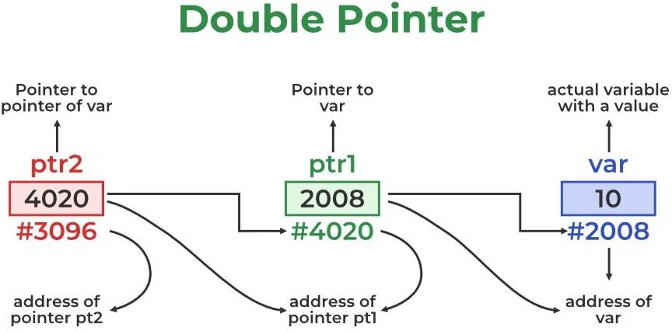

The above diagram shows the memory representation of a pointer to a pointer. The first pointer ptr1 stores the address of the variable and the second pointer ptr2 stores the address of the first pointer.

## Example:

**int var = 10;**

**int *ptr1 = &var; // storing address of val to pointer ptr.**

**int **ptr2 = &ptr1; // pointer to a pointer declared which is pointing to an integer.**

#include <iostream> using namespace std; int main()

{

int variable = 10;

// Pointer to store the address of variable int* ptr1;

// double pointer to store the address of pointer1 int** ptr2;

// Storing address of variable in pointer1 ptr1 = &var;

// Storing address of pointer1 in pointer2 ptr2 = &ptr1;

// Displaying the value of variable by using both single and double pointers. cout << "Value of variable :- " << var<< "\n";

cout << "Value of variable using single pointer :- " << *ptr1 << "\n"; cout << "Value of variable using double pointer :- " << **ptr2 << "\n"; return 0;

}

**Output**

Value of variable :- 10

Value of variable using single pointer :- 10 Value of variable using double pointer :- 10

# How to Declare a Pointer to a Pointer in C ++?

Declaring a Pointer to Pointer is similar to declaring a pointer in C++. The difference is we have to use an additional * operator before the name of a Pointer in C++.

**Syntax of a Pointer to Pointer (Double Pointer) in C++:**

**data_type_of_pointer **name_of_variable = & normal_pointer_variable;**

# What will be the size of a pointer to a pointer in C++?

In the C++ programming language double pointer behave similarly to a normal pointer. So, the size of the variable of the double-pointer and the size of the normal pointer variable is always equal.

## Below is a C++ program to check the size of a double pointer:

#include <iostream> using namespace std;

// Driver code int main()

{

int val = 169; int* ptr = &val;

int** double_ptr = &ptr;

cout << " Size of normal Pointer: " << sizeof(ptr) << "\n";

cout << " Size of double Pointer: " << sizeof(double_ptr) << "\n"; return 0;

}

**Output**

Size of normal Pointer: 8 Size of double Pointer: 8

**Note:** The output of the above code also depends on the type of machine which is being used. The size of a pointer is not fixed in the C++ programming language and it totally depends on other factors like CPU architecture and OS used. Usually, for a 64-bit Operating System, a size of 8 bytes memory and for a 32-bit Operating system, a size of 4 bytes memory is assigned.

# Lab Tasks

1. Create a program to perform a matrix addition and subtraction by using two-dimensional array.
2. Create a program that allows the user:
   * To insert an element at a specific position in an array.
   * To delete an element from a given position in the array.
3. Declare an integer array arr with 5 elements and initialize it with values 10, 20, 30, 40, and

50. Declare a pointer arrPtr and assign the address of the first element of the array to it. Use pointer arithmetic to print the values of all elements in the array using the pointer Increment the pointer to point to the next element and print the updated value. Repeat this process for each element in the array. Modify the values in the array through the pointer by doubling each element. Print the modified array using both array notation and pointer notation.

1. Declare two integer variables, num1 and num2, and initialize them with values of your choice. Declare two integer pointers, ptr1 and ptr2. Assign the addresses of num1 and num2 to ptr1 and ptr2, respectively. Implement a function swapUsingPointers that takes two integer pointers as parameters and swaps the values they point to. Call the swapUsingPointers function with ptr1 and ptr2 as arguments to swap the values of num1 and num2. Print the values of num1 and num2 after the swap to verify that the values have been successfully swapped.
2. Declare a variable num of type integer and initialize it with a value of 42. Declare a pointer variable ptr that can store the address of an integer. Assign the address of the num variable to the pointer ptr. Print the value of num using both the variable and the pointer. Change the value of num through the pointer and print the updated value of num.
3. Create a program that initializes two 3x3 matrices (matrixA and matrixB) with integer values. You can either initialize them manually or use user input. Implement a function to print the original matrices (matrixA and matrixB). Implement a function transposeMatrix that takes a matrix as input and returns its transpose. Print the original matrices and their transposes. Implement a function sumMatrices that takes two matrices as input and returns the matrix resulting from their sum. Print the original matrices and the result of their sum. Allow the user to input the values for the matrices. Modify the program to initialize matrices based on user input. Implement error handling to ensure that the user provides valid dimensions and values for the matrices. Display appropriate error messages if the dimensions or values are invalid.